Correlation Matrix of CITRC MSD Data

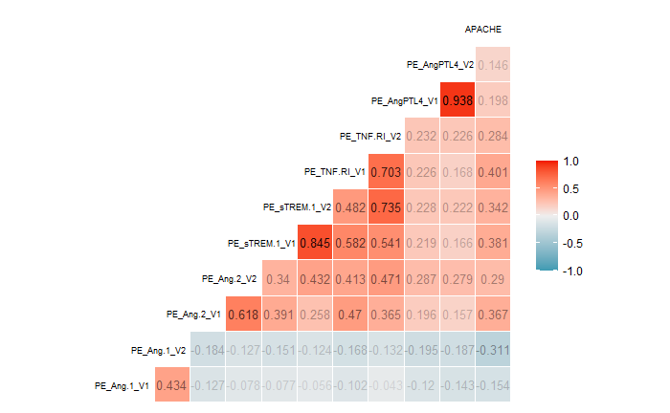

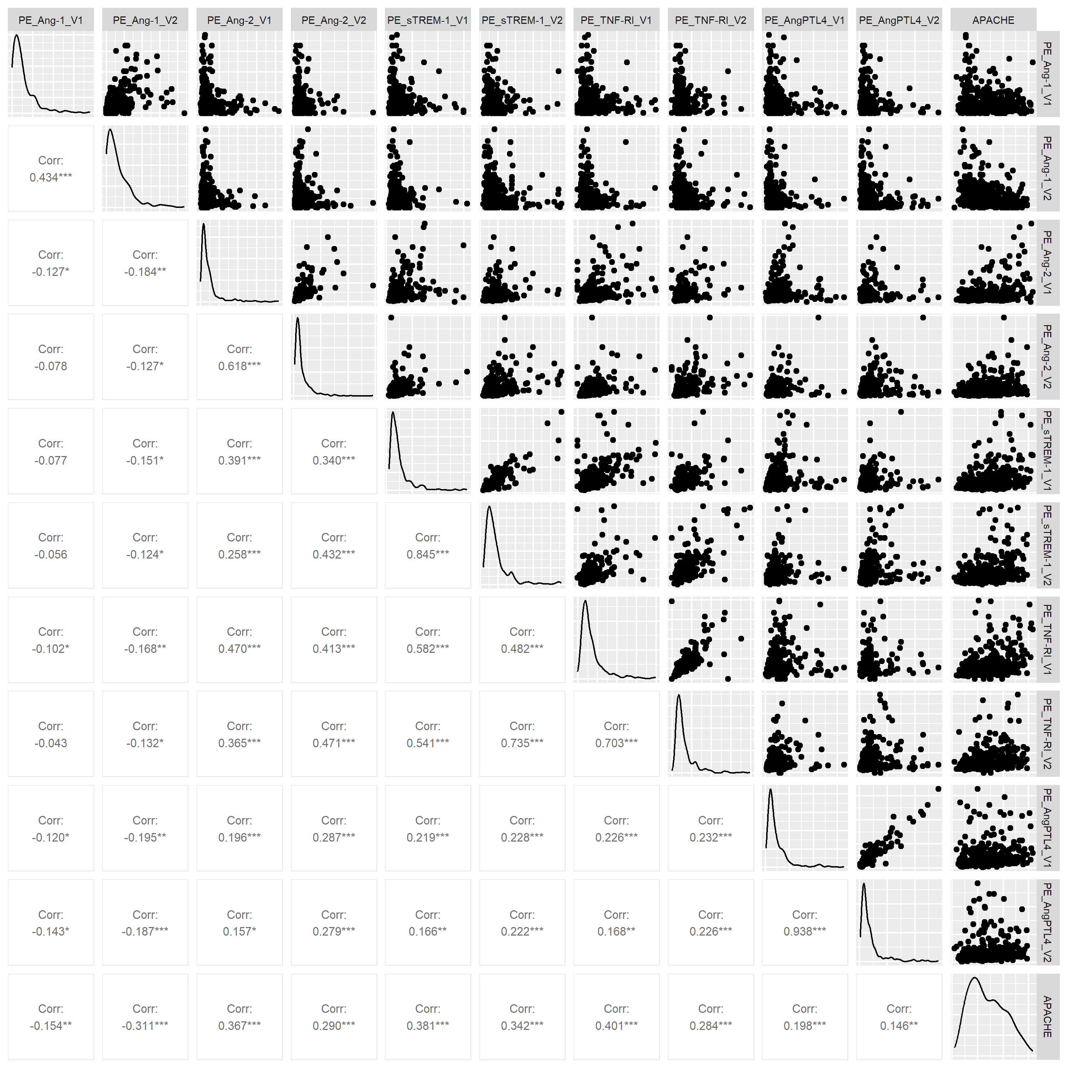Pairs Plot of CITRC Data